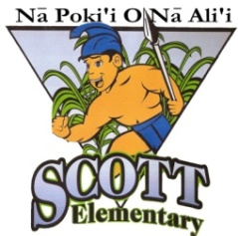
Alvah Scott Elementary Career Day 2016
Speakers Needed

Dear Alvah Scott Families,

As part of our college and career readiness standards, we will once again in the 2016-2017 school year, be having a Career Day for our students to learn about different jobs and occupations.

Career Day will be held on Friday, October 7, 2016, from 8:00 am – 11:00 am. We are in the process of finding speakers for this day and are asking for your assistance. Career Day becomes an even more exciting experience for our students when members of their own family speak to our classes. Each speaker will do two or three presentations that will last approximately 20 – 30 minutes, to share information about his/her occupation and hold a question and answer period.

If you can assist us by participating in this activity as a guest speaker or know of someone who could, please fill out the bottom portion of this flyer and have your child return it to his or her homeroom teacher.

Please note that this request will be going out to families of all students. We only have a limited amount of guest speakers which we can accommodate; therefore, we may not be able to use everyone who replies. Your support for your child and Alvah Scott Elementary School is greatly appreciated. Please contact me at 483-7220 ext. 274 if you have any questions.

Sincerely,

Brad Kusunoki
School Counselor
---------------------------------------------------------------------------------------------------------------------

I am willing to be a 2016 Career Day Speaker

Name:__________________________________________________________

Occupation:______________________________________________________

Child’s Name:_______________________________ Grade:_________________

Telephone Number(s):______________________________________________

Please cut and return this portion to your child’s homeroom teacher.

